“Trust in the LORD and do good;
Dwell in the land and cultivate faithfulness.
Delight yourself in the LORD;
And He will give you the desires of your heart.”
-- Psalm 37:3-4
- Please show all your work! No partial credit will be given for incorrect answers with no work shown. Please draw a box around your final answer.
- Calculators are permitted, but no notes, text, laptops, PDAs, or electronic dictionaries. Cell phones should be muted and left in your pocket or bag.
- Table 3 is attached to the back. You may detach it for your reference.
Total marks: 70

- A particular FDG-PET (fludeoxyglucose positron-emission tomography) screening test for non-Hodgkin’s lymphoma has a 9% false-positive rate (91% specificity) and 88% sensitivity (i.e., 88% of lymphomas are caught by the screening process).
  - Suppose the screening test is applied to 120 patients, of which 27 have non-Hodgkin’s lymphoma. Draw an event tree for the outcomes of the test, and label the tree with probabilities for each branch of the tree. [5]
(has lymphoma: 22.5%) (no lymphoma: 77.5%)
(test +: 88%) (test -: 12%) (test +: 9%) (test -: 91%)
(has, +: 19.8%) (has, -: 2.7%) (no, +: 6.975%) (no, -: 70.525%)
  - On average, how many people in this group will test positive for non-Hodgkin’s lymphoma? [3]
19.8% + 6.975% = 26.775%
26.775% (120) = 32.13 people
  - If a patient tests positive using this test, what is the probability that the patient really has non-Hodgkin’s lymphoma? [3]
19.8% / 26.775% ≈ 73.95%
- Mark each of the following variables as categorical (G), ordinal (O), discrete (D), or continuous (C). [5]
  - Number of nurses in a hospital Discrete
  - Blood glucose level (mg/dLi) Continuous
  - Location of injury: e.g., knee, lower back, shoulder, chest, etc. Categorical
  - Whether a woman is pregnant or not Categorical
  - Hospital wait time, coded as 0-30mins, 30-60mins, 1-2hrs, or ≥2hrs Ordinal
- The diagram below is a normal probability plot of log-transformed values of beryllium lymphocyte proliferation (a screening test for chronic beryllium disease). (The scale is along the left edge.) How does the distribution differ from a normal distribution? Sketch the distribution, highlighting where it is non-normal. [4]
E L Frome, M H Smith, L G Littlefield, R L Neubert, and S P Colyer, “Statistical Methods for the Blood Beryllium Lymphocyte Proliferation Test”, Environ Health Perspect. 1996 October; 104(Suppl 5): 957–968.
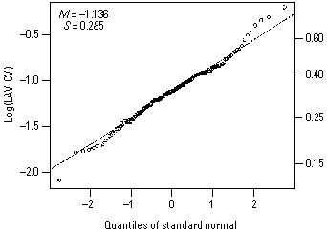
Values at the low end are lower than normal; values at high end are higher than normal, so the distribution has slightly thicker tails than normal
- In a population of nursing students, would you expect marital status (married or not) and eye colour (e.g., brown vs. other) to be independent? Why or why not? [3]
Yes, independent – prob. of being married does not depend on eye colour.
Nursing students with brown eyes have same chance of being married
as nursing students with other colour of eyes.
- The age of a population of nurses is assumed to be normally distributed with an average age of 41.0 years and standard deviation of 8.2 years.
  - What is the 60th percentile age? [2]
(T3) z ≈ 0.25
41 + 0.25(8.2) = 43.05 years
  - What fraction of nurses in this population are in their thirties (30-39 years old)? [3]
y = 30 ⇒ z = (30-41)/8.2 ≈ -1.34 ⇒ (T3) area = 0.0901
y = 39 ⇒ z = (39-41)/8.2 ≈ -0.24 ⇒ (T3) area = 0.4052 (or y = 40 ⇒ area = 0.4522)
0.4052 – 0.0901 = 31.51% (or 36.51%)
  - If we select four nurses from this population, what is the probability that their average age is within ±2 years of the mean? [3]
z = ±2/(8.2/sqrt(4)) = ±2/4.1 ≈ ±0.49
(T3) area = 0.6879 – 0.3121 = 37.58%
  - If we did not know the mean age, how many nurses would we need to query to estimate the mean age to within ±2 years, with 95% confidence? [4]

95% conf ⇒ (T3) z = ±1.96 ⇒ 1.96 = 2/(8.2/sqrt(n)) ⇒ n = (1.96(8.2)/2)² ≈ 65
- Consider a sample space of patients in a community health program. Let A be all patients in the program who have Alzheimer’s disease, and B be all with in-home care. Translate each of the following statements into probability notation using A and B, and draw a Venn diagram in the box provided, shading in the region described. (If it’s a conditional probability, write “not applicable” in the Venn diagram.)
  - 7 out of every 20 patients in this program have Alzheimer’s disease. [2]
P(A) = 0.35
A
  - 28% of patients in this program are Alzheimer’s patients with in-home care. [2]
P(A ∩ B) = 0.28
B
  - 65% of patients in this program either have Alzheimer’s or have in-home care. [2]
P(A u B) = 0.65
B
  - What fraction of patients in this program do not have in-home care? [3]
P(B) = P(A u B) – P(A) + P(A ∩ B)
= 0.65 – 0.35 + 0.28 = 0.58
so P(B^{c}) = 1 – 0.58 = 0.42 = 42%
  - What fraction of Alzheimer’s patients in this program have in-home care? [3]
P(B|A) = P(A ∩ B) / P(A)
= 0.28 / 0.35 = 0.80 = 80%
  - In this program, is having Alzheimer’s independent of having in-home care? Why or why not? [3]
No: 42% = P(B) ≠ P(B|A) = 80%
Alzheimer’s patients are more likely to have in-home care.
- The list below shows the average life expectancy for nine nations.
Construct a relative frequency histogram, classifying the data by bins of 10 years. [4]
Italy: 80 | Canada: 81 | Thailand: 73
Haiti: 61 | Peru: 71 | South Africa: 49
Singapore: 82 | Kenya: 58 | Russia: 66
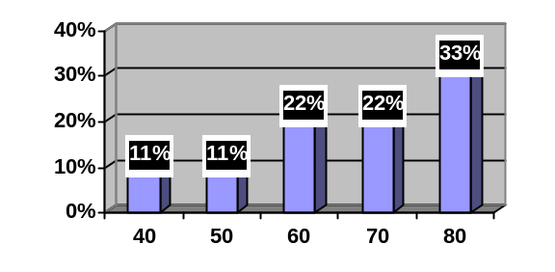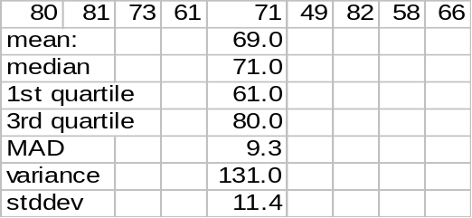
  - Calculate the mean of this sample. Please show your work. [2]
69
  - Calculate the standard deviation of national life expectancy in the sample. Please show your work. [5]
~11.45
  - Draw a boxplot for the data. Show all your work. [4]
min=49, Q1=59.5, med=71, Q3=80.5, max=82
  - Does the distribution appear normal? Why or why not? [2]
No, skewed to the left
  - If the sample size were increased to 90, would the distribution of national life expectancy appear more normal? Why or why not? [3]
No – this is the distrib of the population (not SDSM), which we don’t know.

